CITIZEN’S CHARTER

Directorate of Forensic Science Services,
Ministry of Home Affairs
Block No. 9, 8th Floor, CGO Complex
New Delhi – 110003

Tel No: 011-24366781, 24361085
Fax No. 011-24362819

Website: http://dfs.nic.in

The Directorate of Forensic Science services (DFSS) was created in the year 2002 by Ministry of Home Affairs, Govt. of India, after bifurcation from BPR&D, based on the recommendations of National Human Rights Commission and Padmanabhaiah Committee on Police Reforms. The Gazette notification to this effect was issued by MHA vide its Order no. 25011/41/2001-GPA.II/PM-II on December 31, 2002. It is headed by Director-cum-Chief Forensic Scientist.

Mission Statement of DFSS:

The Mission statement of the Directorate of Forensic Science Services is to render 'High quality and credible forensic services' to justice delivery system.

Central Forensic Science Laboratories under DFSS:

Directorate of Forensic Science Services administers the work of six Central Forensic Science Laboratories (CFSL) located at Kolkata, Hyderabad, Chandigarh, Bhopal, Pune and Guwahati. CFSL Kolkata is the oldest Institution, established in 1957, CFSL Hyderabad established in 1968 and CFSL Chandigarh Established in 1972. The new CFSLs have been established at Bhopal, Pune & Guwahati in the year 2011.
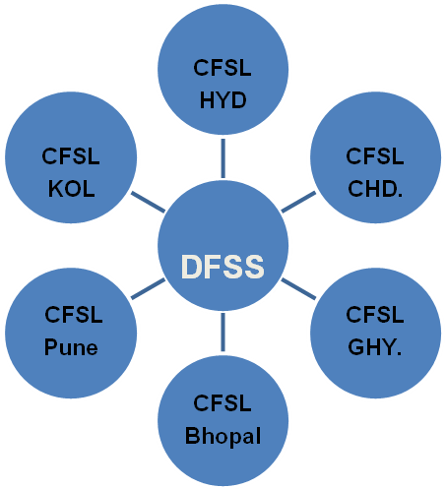
Charter of Duties of Directorate of Forensic Science Services:

As per MHA's Resolution No. 25020/50/2010-PM.II Dated Nov. 29, 2010; following are the Charter of Duties of the Directorate of Forensic Science Services, MHA, New Delhi:

- To provide high quality and on time Forensic Services to Criminal Justice Delivery System by creating capacity and capability at the central level and providing technical and financial support and assistance to forensic institutions in the states and UTs.

- To develop new technologies and create new scientific knowledge to assist the Criminal Justice System.

- To encourage Research & Development in various areas of forensic science & strengthen forensic services by arranging and instituting financial grants and Fellowship schemes for intramural and extramural R&D schemes.

- To establish linkages with National and International Scientific, Technical and Forensic Institutions and Universities for cooperation through Transfer of Technology, skill development, exchange of scientific personnel and sharing of information.

- To promote Quality Assurance and Quality Control in Forensic Testing by arranging technical and financial support for the development of forensic standards and uniform standard Operating Procedures.

- To disseminate and promote knowledge in the field of application of Science & Technology by supporting /organising Awareness Programmes, symposium, seminars, Hands on workshop and national /international Conference.

- To formulate Plan and Policies to promote capacity building in Forensic Science in the country.

- To develop National database on various forensic indices to control recidivism, repeat crimes and strengthen Home Land Security.

- To promote excellence in Forensic Services & R&D by instituting awards & incentive programmes.

- To assist and advice the Central and State Governments in all Forensic Science matters and extend Forensic Science Assistance to manager National Disaster/calamities.


JURISDICTION OF THE SIX CFSLs : AS PER MHA ORDER NO. 25020/61/13/FW/MHA PUBLISHED IN THE GAZETTE OF INDIA ON JULY 26, 2013

CFSL Chandigarh  - Jammu & Kashmir  - Punjab  - Himachal Pradesh  - Chandigarh (UT)  - Uttarakhand  - Delhi  - NCR & Haryana | CFSL Bhopal  - Madhya Pradesh  - Uttar Pradesh  - Rajasthan  - Chhattisgarh
CFSL Hyderabad  - Andhra Pradesh  - Tamil Nadu  - Kerala  - Lakshadweep  - Karnataka  - Puducherry | CFSL Guwahati  - Assam  - Manipur  - Mizoram  - Meghalaya  - Sikkim  - Nagaland  - Arunachal Pradesh  - Tripura
CFSL Kolkata  - Orissa  - Bihar  - Jharkhand  - West Bengal  - Andaman & Nicobar Islands | CFSL Pune  - Maharashtra  - Gujarat  - Goa  - Daman & Diu  - Dadar & Nagar Haveli

Grievance Redressal Mechanism

Name & Contact details of Public Grievance Officer in r/o DFSS HQs and its six outlaying Units

Director-cum-Chief Forensic Scientist
Directorate of Forensic Science Services,
Block No. 9, 8th Floor, CGO Complex,
New Delhi – 110 003

Telephone : +91-11-24362676
Tele-Fax : +91-11-24362819
E-mail : cfs-dfss@nic.in

Expectation from complainant
1. The complainant should provide clear statement of grievance indicating the background and officials/channels previously approached for redress along with copies of correspondence.

2. The complainant should provide complete mailing address including pin code no., contact numbers and e-mail address for correspondence.

3. The complainant should provide prompt response to the queries.

Grievance Lodging Process

By hand, By post, By fax & by email.

Right to Information

The Directorate of Forensic Science Services has implemented the Right to Information Act, 2005 and has put in place all necessary information on the website of the Directorate. At present, there are 7 Central Public Information Officers (CPIOs) of the level of Director/Deputy Director/ Assistant Director.

Further, Director-cum-Chief Forensic Scientist of Directorate of Forensic Science Services and Director/Heads of six CFSLs : Kolkata, Chandigarh, Hyderabad, Pune, Bhopal & Guwahati have also been designated as Appellate Authorities to entertain appeals and to pass appropriate orders thereon.

Disposal of appeals/applications received under RTI Act, 2005 is the responsibility of Appellate Authority/CPIOs in the Directorate and its Laboratories.

Stakeholders/Clients

Stakeholders
1. Central Govt. Ministries/Deptts. and State Governments
2. Law Enforcement Agencies
3. R&D Institutions
4. Universities & Educational Institutions
5. Scientists & Technologists



Month and year for next review of the Charter : April 2019

